**Structural Health Monitoring to Quantify the Influence of Train Crossings on the Long-Term Performance of the Manhattan Bridge**

John Braley, Saeed Babanajad, Adriana Trias, Dom wirkijowski, Franklin Moon

Center for Advanced Infrastructure and Transportation (CAIT), Rutgers University

December 18, 2018

The purpose of this document is to provide NYCDOT the results of the initial bridge survey as well as a detailed breakdown of the instrumentation plan for the next stage of long-term monitoring that Rutgers Team is planning to conduct on the Manhattan Bridge. In addition to reviewing and providing comments or changes to this project plan, prior to initiating the long-term monitoring campaign, there are a few logistical arrangements that need to be addressed. The details of these items are discussed thoroughly throughout the plan and summarized here for convenience:

1. Establish the protocol for continuous visits of the site for about 1-2 weeks period during the January (including scaffolding and instrumentation)
2. Provide structural drawings of approach spans
3. Provide access to electrical power
4. Approve the location of the long-term data acquisition system enclosure
5. Approve the scaffolding plan at the locations of envisioned instrumentations
6. Approve spot paint removal, micro-dot welding, and sensor protection enclosure using epoxy

## State of progress

On November 16, 2018, a preliminary data survey was conducted on the Manhattan Bridge as part of a larger effort to better understand the effect of rail splice misalignment on bridge performance. The test was particularly conducted on the south side of the bridge between Division and E Broadway streets. The survey was performed to assess the suitability of locations for more in-depth instrumentation, and to gain further understanding of the nature of the coupled dynamic system (train-bridge interaction).

As shown in Fig. 1, the accelerometers were easily installed and removed without any damage to the bridge elements due to the magnetic mounts. The sensors were PCB (model 393A03) ceramic shear ICP accelerometers with a frequency range of 0.5 Hz to 2000 Hz and a measurement range of ±5g. Fig. 2 below illustrates the typical sensor locations.

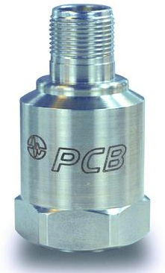

Figure 1 Typical Model of Accelerometer

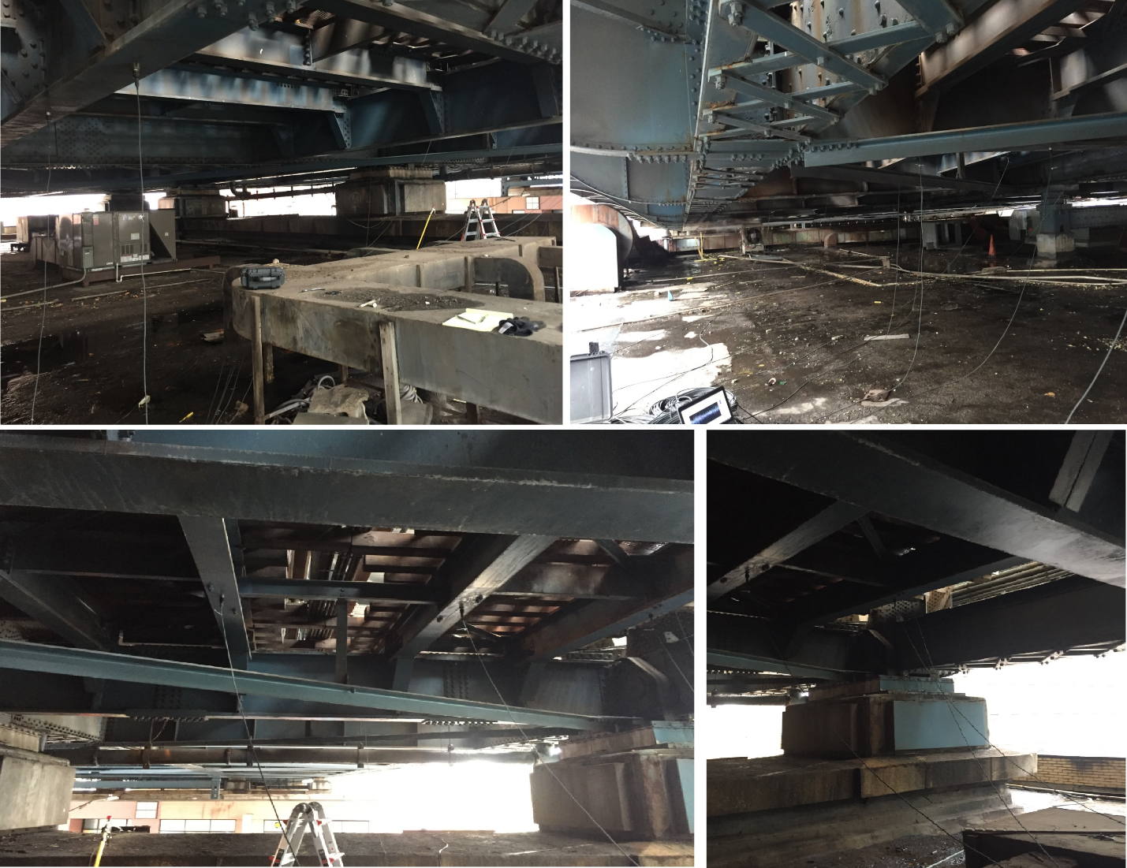

Figure 2 Accelerometer Locations (South Bound)

Before conducting any measurements, the Rutgers team surveyed the problematic rail splices on the first approach span on the Manhattan side(both north and south sides). Fig. !!! provides a map of rail splicing joints with a number assigned to each based on joint’s visual condition, where 1 corresponds to good and 3 corresponds to serious condition.

Figure !!! Rail Splicing Joints Map for Manhattan Approach

Over twenty sensors were deployed on the underside of the Manhattan Bridge. They were affixed to the bridge superstructure with magnets and were removed at the conclusion of the survey. Operational acceleration was recorded for over 30 train crossings (A and B rails). The resulting data confirms that misaligned splices are consistently causing an increase in structural acceleration and this acceleration is undoubtedly resulting in a significant increase in member stress levels. The next phases of monitoring will serve to quantify this amplification.

The following document provides a summary of the gathered data and interpretation.

# Task 2: Results Summary

A sample time history of acceleration during a train crossing is provided below.



**Figure 3 Sample of acceleration data**

It is immediately obvious from the above plot that the location with poor rail alignment is experiencing greater acceleration and in excess of 5g resulting in “clipping” of the data. This is due to the limitations of the sensor (±5g range). While the clipping reduces the accuracy of the data, it remains useful for our purposes of comparison. The following exercise demonstrates the effect this clipping has in the frequency domain.

A data sample was selected which exhibited no over-ranged samples. This data set was subsequently clipped for any value exceeding 2g. An FFT was performed on the clipped and original signals. The resulting frequency content, compared below, shows that clipping the signal serves to increase the contribution of high-frequency content (165 Hz) but does not appreciably increase the lower frequency.



Figure 4 (Left) Percent change in FFT values due to clipping; (Right): FFT of original signal compared to the difference in FFT values

Given the assumption of harmonic, steady-state motion, the displacement is related to acceleration by the equation: $u=\frac{\ddot{u}}{-ω^{2}}$, where ω is the radial frequency of the acceleration. Therefore the displacement due to a given frequency component is the amplitude at that frequency line divided by the square of the radial frequency. Since we are interested in motion that results in deformation of the structure, it follows that we should be most interested in low frequency content that contributes most to the cumulative displacement of the structure.

The sensors employed for this preliminary survey are not able to accurately capture motion below 0.5Hz and thus the resulting data is incapable of accurately predicting displacement. However, it can be seen from just comparing frequency content for different locations that the poorly aligned splice is resulting in greater acceleration amplitudes across all frequency bands, including content below 10Hz. The increase in low-frequency content must, therefore, result in increased displacement and increased stress levels.

|  |  |
| --- | --- |
|  | Location Key |
| Location Key |

Figure 5 Frequency content (FFT) of acceleration

The event characterized with the above plots is not dissimilar to the many other events recorded. The increase in broad-band structural acceleration was observed at locations with misaligned splices for nearly every train crossing event. The amplification appears to be more severe for misaligned splices that are located near the mid-span of a transit beam. While the gathered data unequivocally shows that poorly aligned splices cause increased dynamic amplification; that amplification cannot be quantified due to the limitations inherent to the acceleration data. The next stage of monitoring will seek to capture strain and/or displacement data which can be more directly related to structural performance metrics (e.g. stress).

During the instrumentation and monitoring of the first approach span, a terrestrial laser scanner (LiDAR) was deployed to capture a 3D point cloud that would provide information of the geometry of the structure for future analysis. A total of eight scans were performed under the steel structure as seen in Fig. 6. A visual of the first scan can be seen in Fig. 7, where the purple box represents the location of the LiDAR and the grey image are the millions of points that conform the point cloud. On Fig. 7 are visible the northern fascia girder and its adjacent girder, the floor beams and deck between them, and their supports at Pier 1.

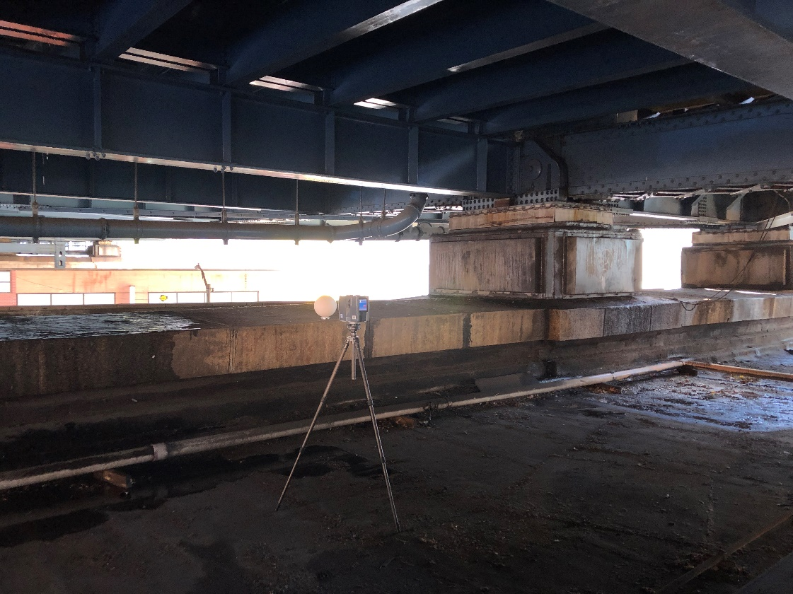

Figure 6 LiDAR scanning process of the first approach span of the Manhattan Bridge

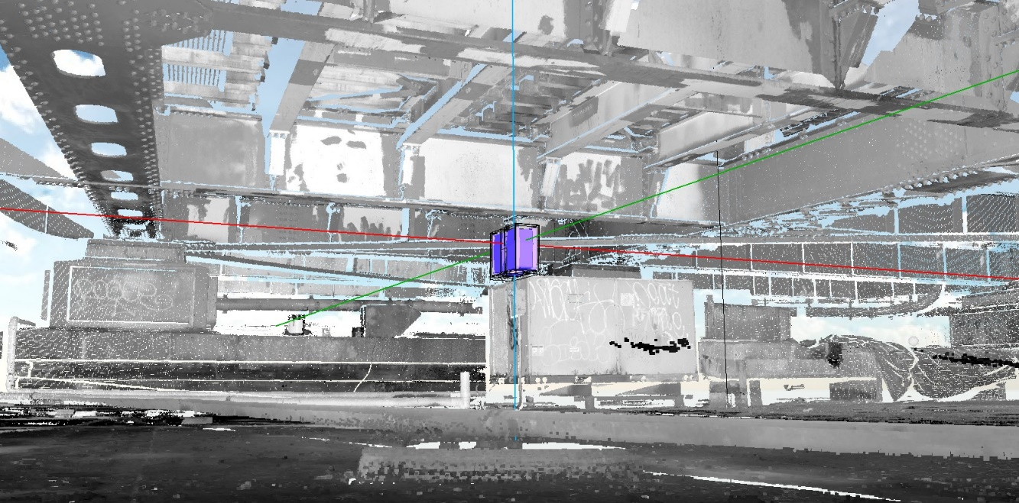

Figure 7 View of scan_01. Location of LiDAR and view of Pier 1

# Task 3 Long-term Instrumentation Plan

This phase of monitoring is meant to fulfill the following objectives:

* Quantify dynamic amplification of flexural stress in transit beams (at good and poor splice locations)
* Quantify dynamic amplification of shear stress in transit beams (good and poor splice locations)
* Quantify dynamic amplification of flexural stress in floor girders
* Quantify dynamic amplification of shear stress in floor girders
* Monitor and compare stress in web of floor girder caused by out-of-plane deformation as a result of stiffener plate detailing (locations with and without cracking)

To meet these objectives, an instrumentation plan has been developed to record operational responses at critical locations (e.g. experience maximum response, have minimal reserve capacity, or have demonstrated inadequate performance such as fatigue cracks). They will be spatially distributed to provide various responses (e.g. shear strain, axial strain) in different load carrying members (e.g. transit beams, floor girders).

## Sensor Layout

The figure below depicts the layout of strain gauges on span 1 of the Manhattan approach for the south transit (west subway) framing. This layout calls for a total of 36 gauges and is intended to acquire global responses.

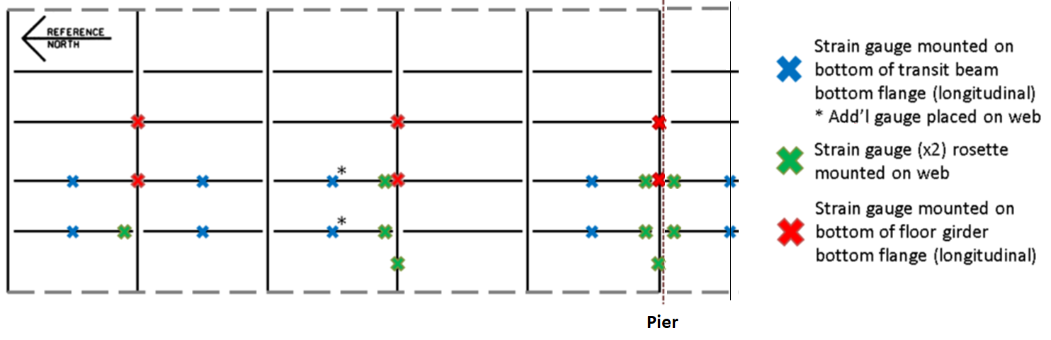

Figure 8 Instrumentation Layout for Global Response Monitoring

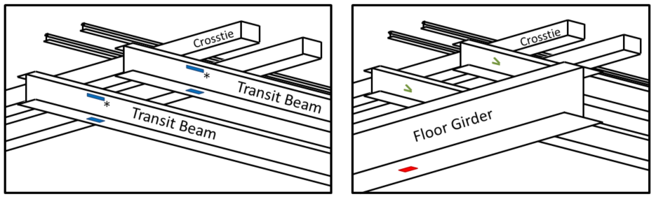

**Figure 9 Typical Gauge Mounting Locations**

Gauges will also be installed at locations that have demonstrated to be prone to fatigue cracking. These cracks have occurred where the transit beams frame into the floor girder, as detailed in the figure below. The connection detail features a stiffener plate terminating in the web of the floor girder, thereby applying large out-of-plane forces on the web. In some locations, the stiffener plate has been retrofitted to provide connection to the bottom flange. Gauges will be installed in locations where cracking has been recorded as well as locations that have the original detail and those that have been retrofitted to provide comparison. Responses at these locations will serve to monitor crack growth/formation resulting from dynamic loading and assess the performance of previously implemented retrofits. A total of 8 gauges will be installed for monitoring fatigue cracks. Depending on the locations, arch crack opening sensors will be placed across the cracks.

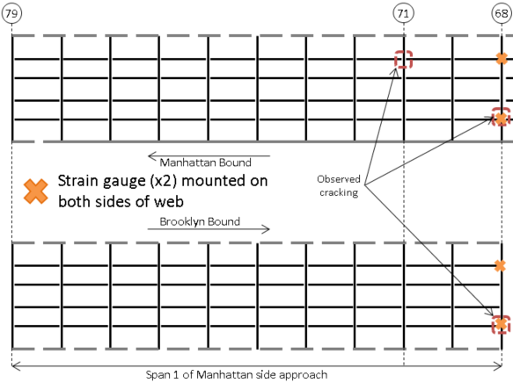

Figure 10 Instrumentation Layout for Fatigue Crack Monitoring

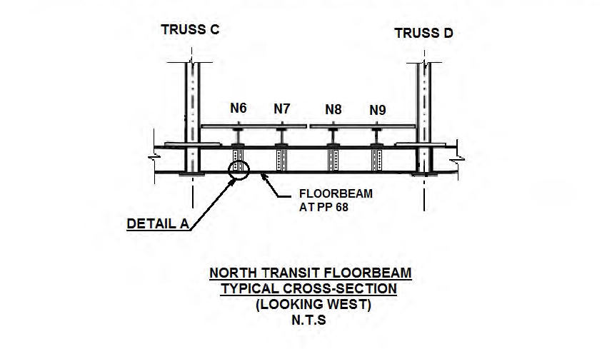 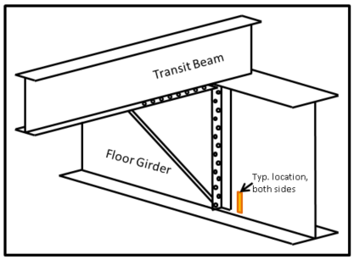

Figure 11 Typ. Framing Detail in Locations with Fatigue Cracking

Figure 12 Typ. Gauge Location for Fatigue Crack Monitoring

Temperature gauges will also be installed to monitor the temperature of the structure. Their locations will be as indicated in the diagram below:

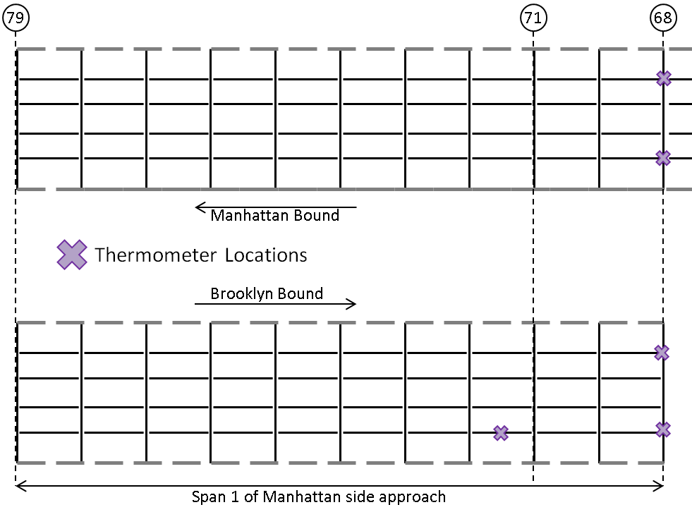

Figure 13 Instrumentation Layout for Temperature Monitoring/Compensation

## Description of Instrumentation

The optical interrogation unit, as shown in Fig. 14, is capable of monitoring 30-40 sensors depending on sensor types. It can simultaneously accept data from strain gauges, temperature, and other sensors. This unit has a bandwidth of 1460-1620nm and a maximum sampling frequency of 1 kHz.

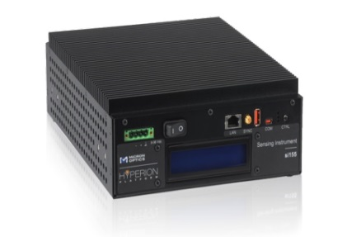

**Figure 14 Photo. Micron Optics si155 Interrogator Module.**

*Processor Unit*

The central processing unit for this project is the Stealth.com, Inc. Model: LPC-100G4 Ultra Small Mini PC with four Gigabit LAN ports. This device is equipped with a 2.26 GHz processor with 8 GB of RAM and a 120 GB Solid State hard drive. It uses a Windows 7 64-bit operating system and is loaded with the Micron Optics program ENLIGHT for sensor interface and data acquisition.

*Remote Monitoring*

An active internet connection is provided by the use of an industrial cellular modem. This connection allows for the manual or automatic transfer of data from the interrogation unit to NYCDOT and any other location.

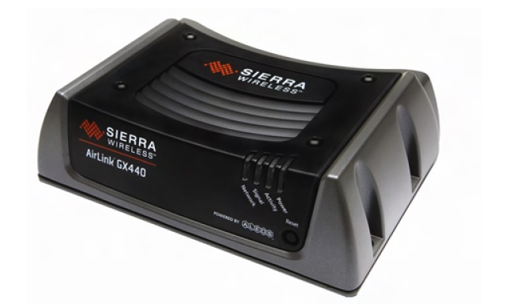

**Figure 15 Photo. Cellular modem and PC remote control interface.**

*FBG Strain Sensors and NEMA Enclosure Box*

The FBGs are protected by NEMA enclosure boxes at the site (see Fig. 16). Note that the boxes will be epoxied to the steel girder and will not damage the girders. All sensors are wired with armored fiber optic cabling to the site control NEMA enclosure that houses the optical interrogator, the central processing system and the cellular wireless. The paint of the steel girders at the locations of sensors will be slightly removed to create a clean surface for installation (at most 3 by 3 inches). This will not impose any damage to the girder. The following photos provide examples of such. Typical NEMA enclosure is shown in Fig.17.

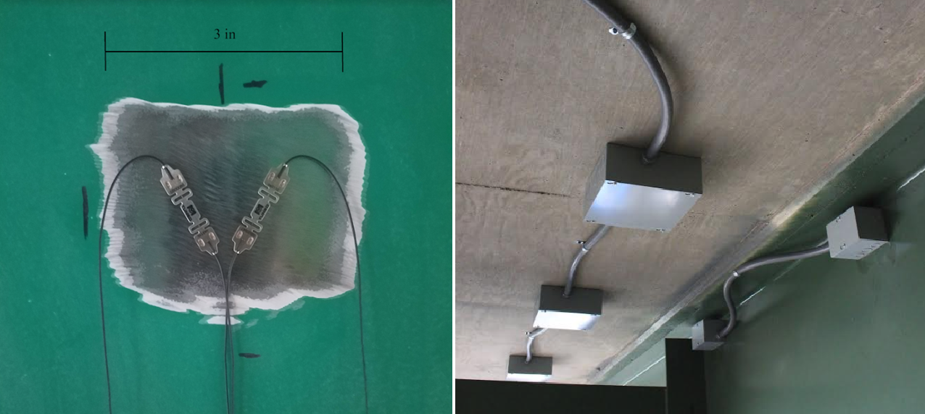

**Figure 16 Photo. Typical Strain gage installation and protection**

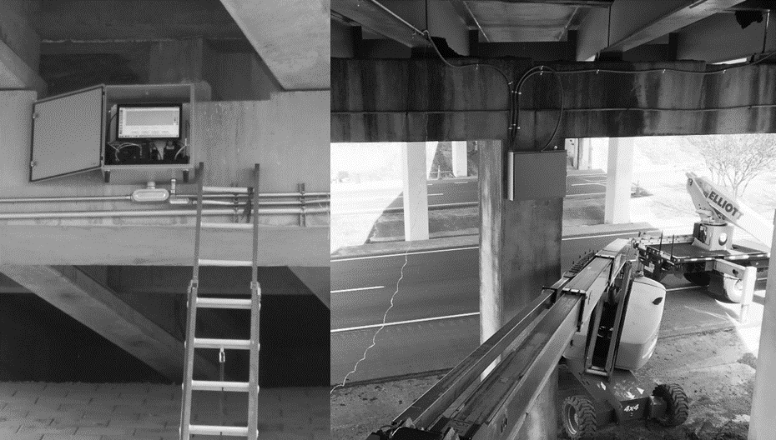

**Figure 17 Photo. Main NEMA Enclosures in Oregon (left) and Georgia (right)**

For the Manhattan Bridge site, it is envisioned to install the main enclosure box to the side of pier concrete wall using 3/8” steel threaded anchors. The enclosure system will not have any contact with the building floor. Fig. 18 shows the approximate location of the enclosure system, where the enclosure will be installed on the side of pier between two pier columns on the south side (to avoid interrupting any potential inspections of the columns). It is desirable to have the power cable close to this area. Fig. 19 also demonstrates the type of steel anchor being assumed for enclosure installation to the pier wall.

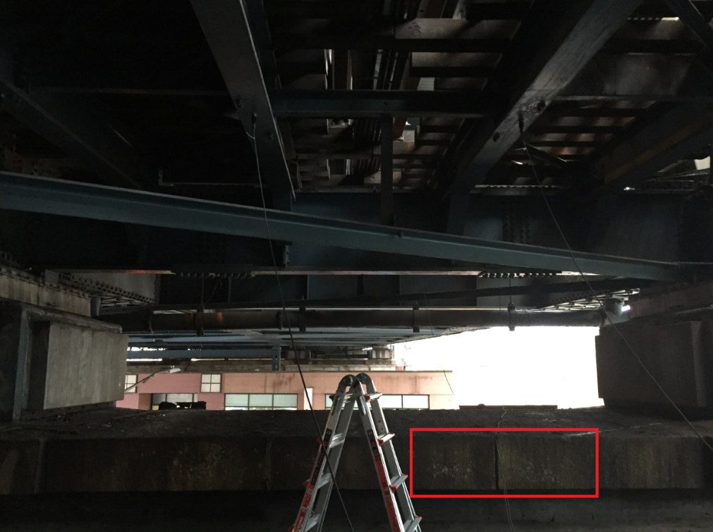

**Figure 18 Photo. Envisioned Location for NEMA Enclosure Installation (South Side between pier columns, attached to the side of pier wall)**

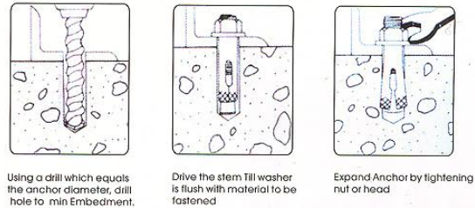

**(a)**

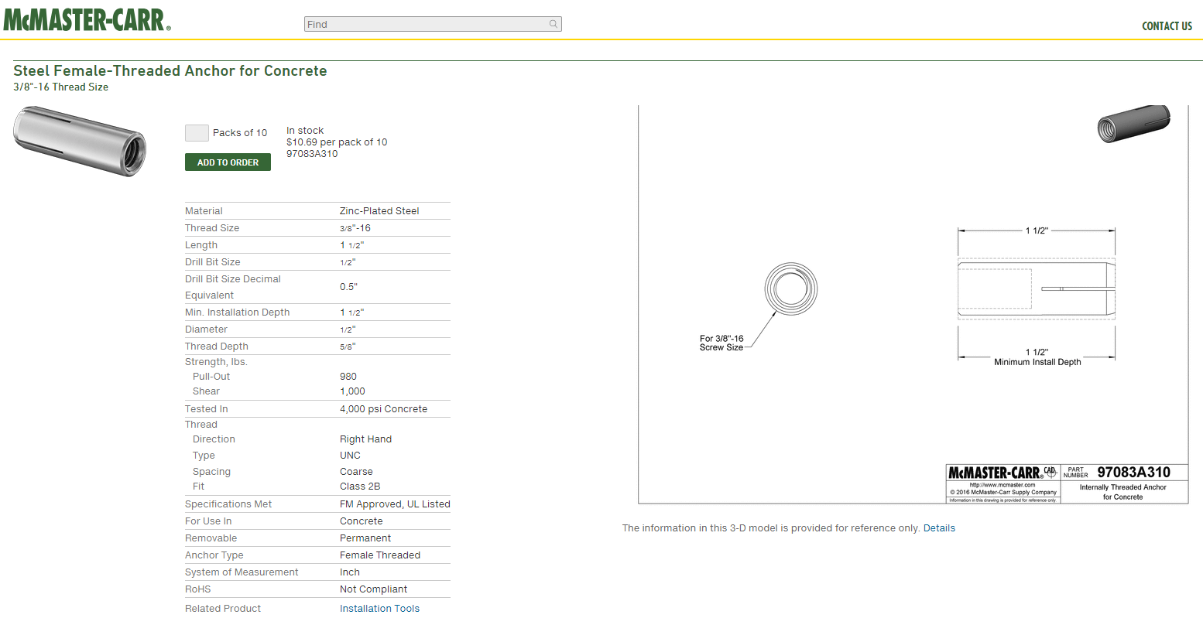

**(b)**

**Figure 19 Type of 3/8” Steel Anchor**

*Necessary Scaffolding Facility for Instrumentation*

Given the length of instrumentation, it is necessary to use scaffolding for installation. Fig. 20 provides examples of the scaffolding frames that have been used before. The height and occupancy requirements (under 20ft and no more than two persons) allow for relatively light-weight scaffolding. As highlighted in Fig. 20, base plates will used for the columns of the scaffolds to distribute the load and further reduce the pressure applied to the roof.

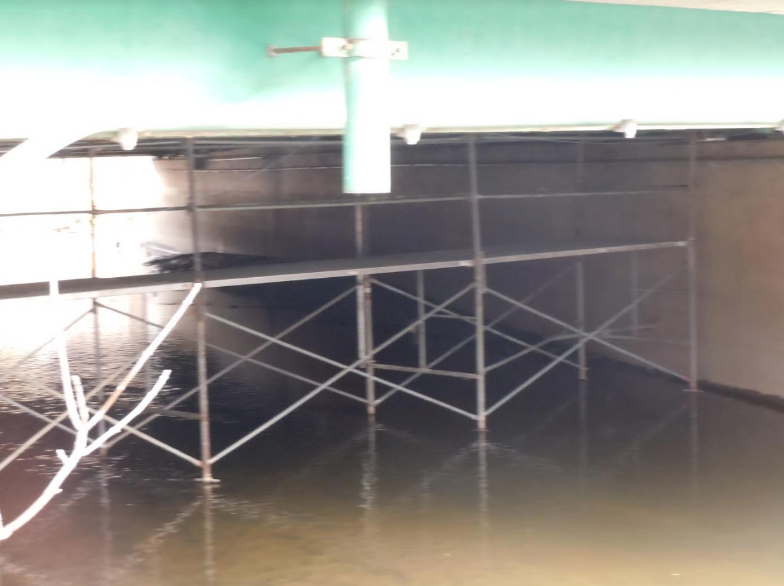

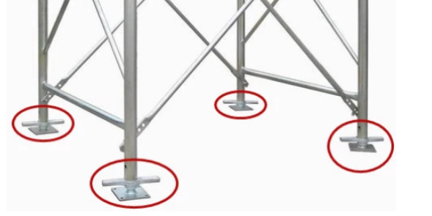

**Figure 20 Typical Scaffolding Facility**

# Work Plan and Timeline

The remaining tasks involved will be:

1) Installation of interrogation unit, sensors, field computer and cellular wireless router within a rated NEMA enclosure at the site (01/02/2018 - 01/31/2018)

2) Development and setting-up the SHM software (01/02/2018 - 01/31/2018)

3) Analyzing the collected data and attending multiple field trips to evaluate different loading scenarios (along with NYCDOT and MTA personnel) (02/01/2018 - 05/31/2018)

4) Training of the NYCDOT and MTA personnel for real-time monitoring of the bridge by use of the real-time system (04/01/2019 - 04/30/2019)

5) Drafting the final report (06/01/2019 - 06/30/2019)

6) Detaching the sensors (06/15/2019 - 06/30/2019)